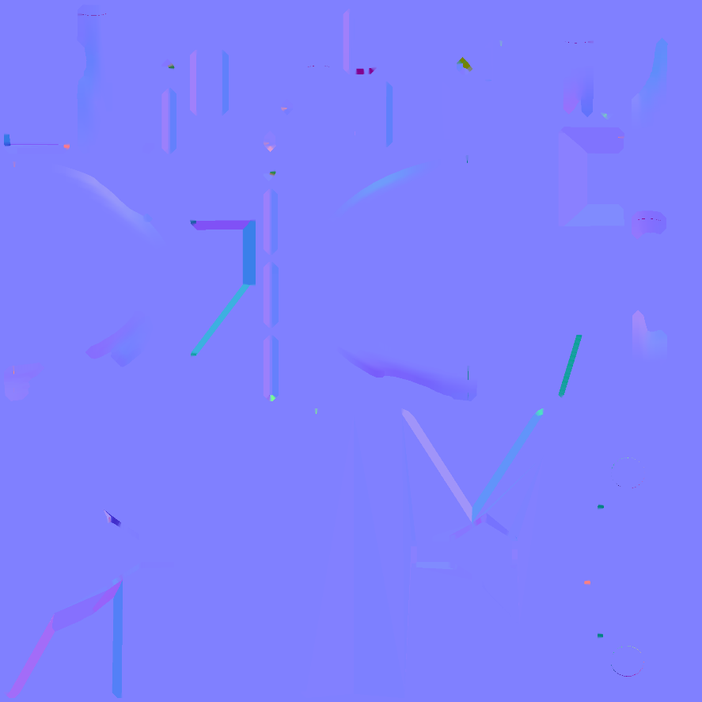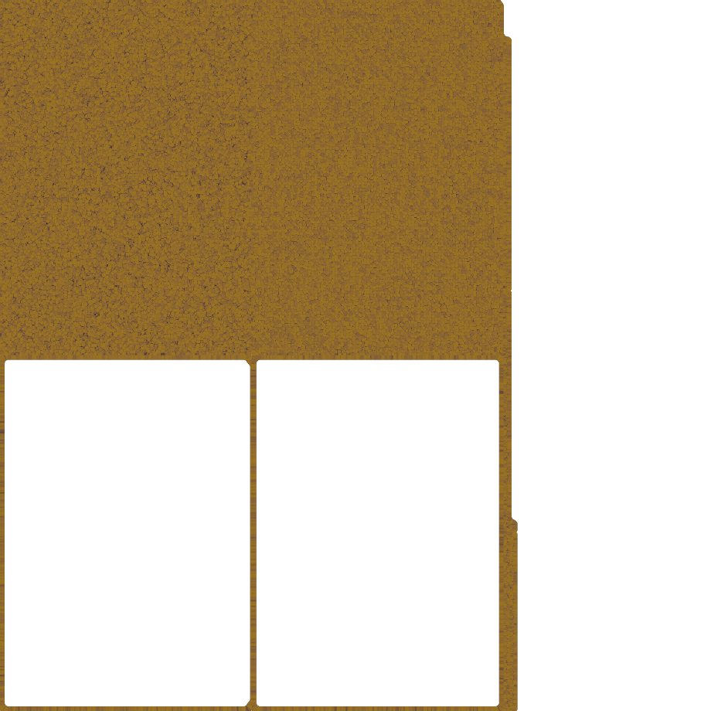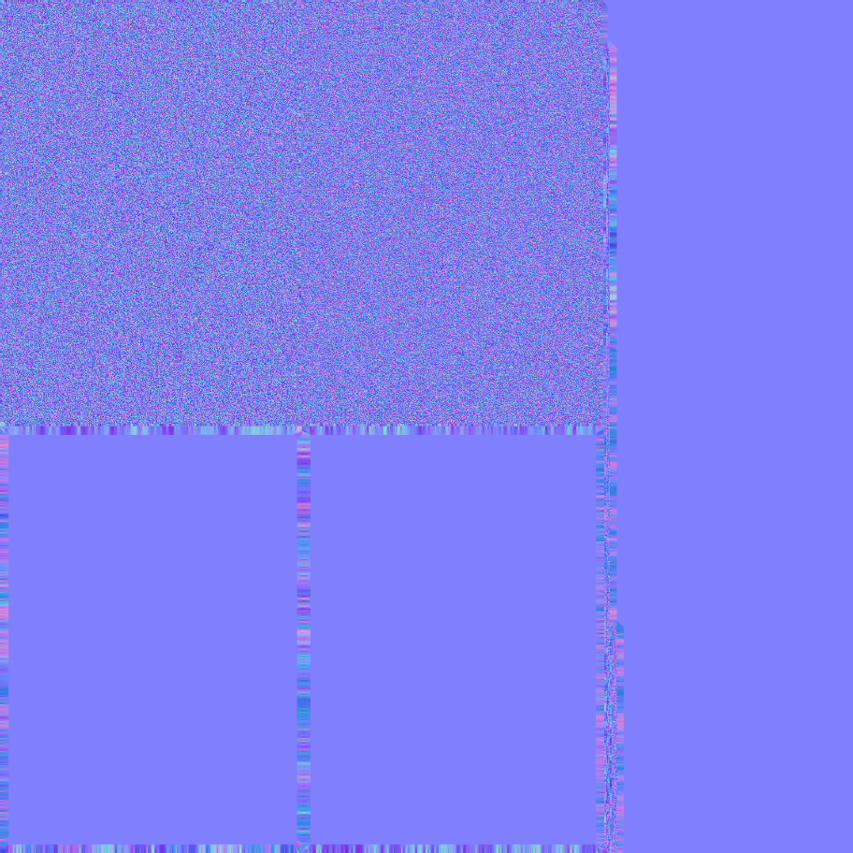

Lock

Clipboard

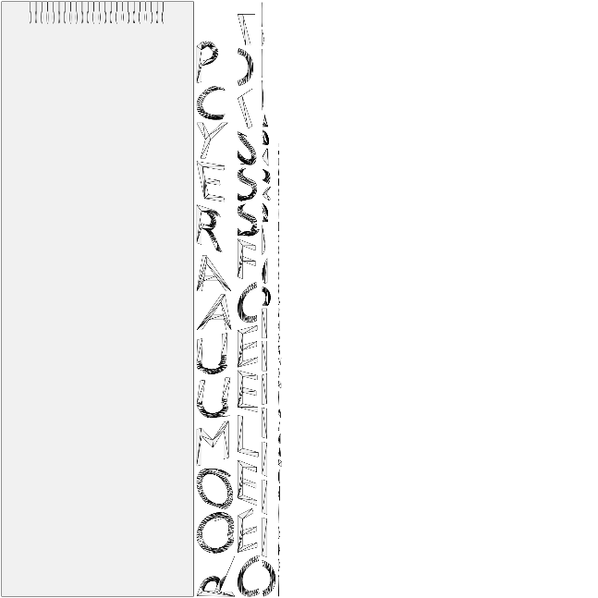

Letter

Albedo Map

Normal Map

UV Unwrap



Exit sign

UV Unwrap

Normal Map

Albedo Map

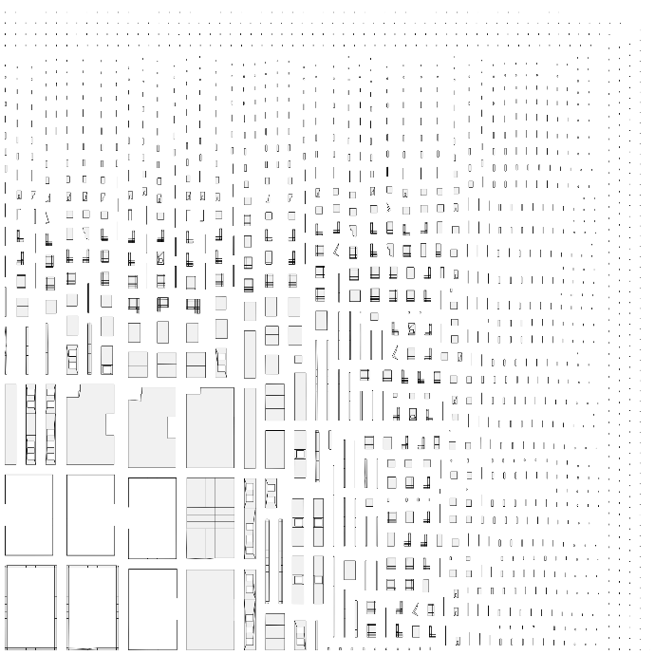

Hospital

Normal Map

UV Unwrap

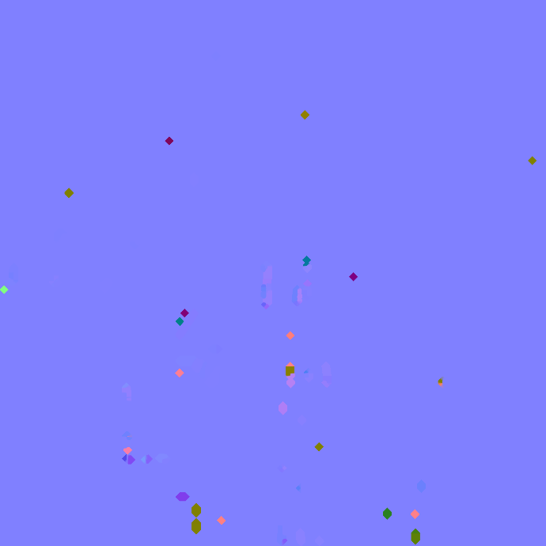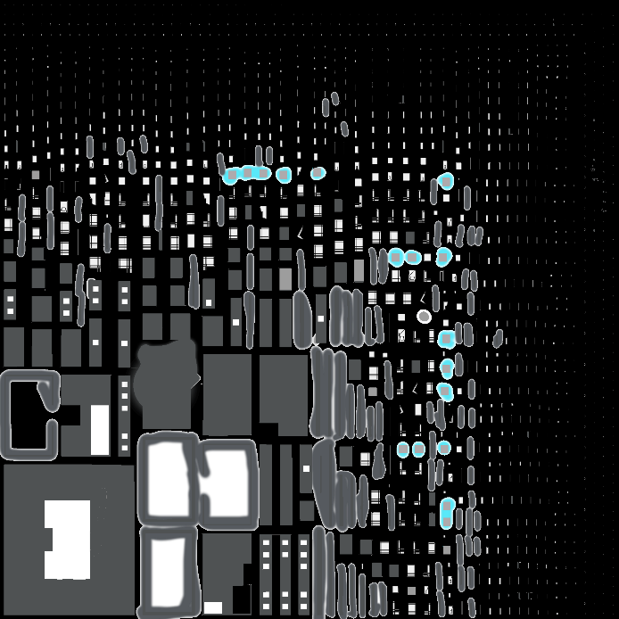

Albedo Map

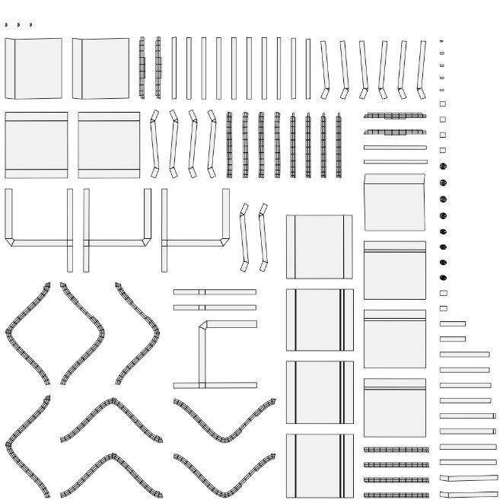

Bench

UV Unwrap

Normal Map

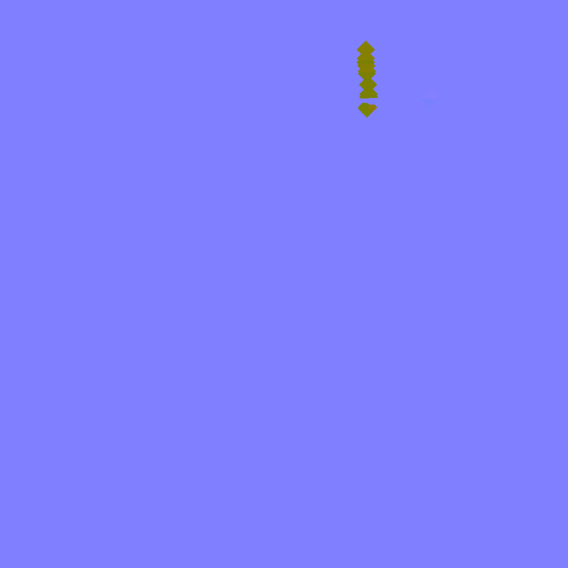

Albedo Map

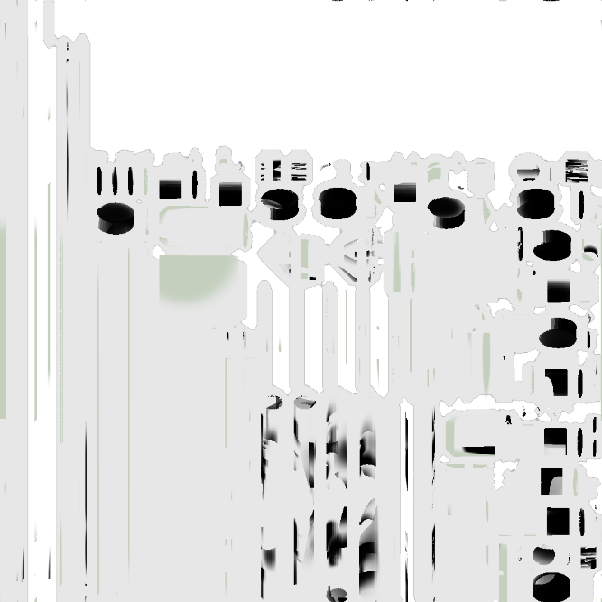

Iv drip

Albedo map

Normal map

UV Unwrap

Albedo map

Normal map

UV Unwrap

Key

Light

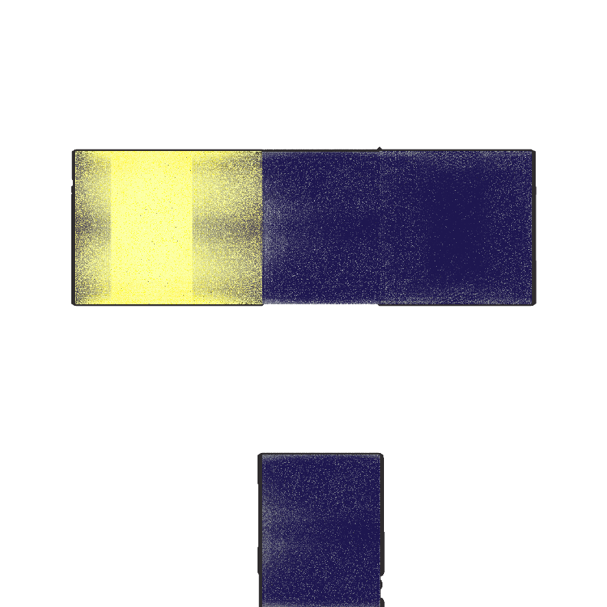

Albedo map

Normal map

UV Unwrap

Pill bottle

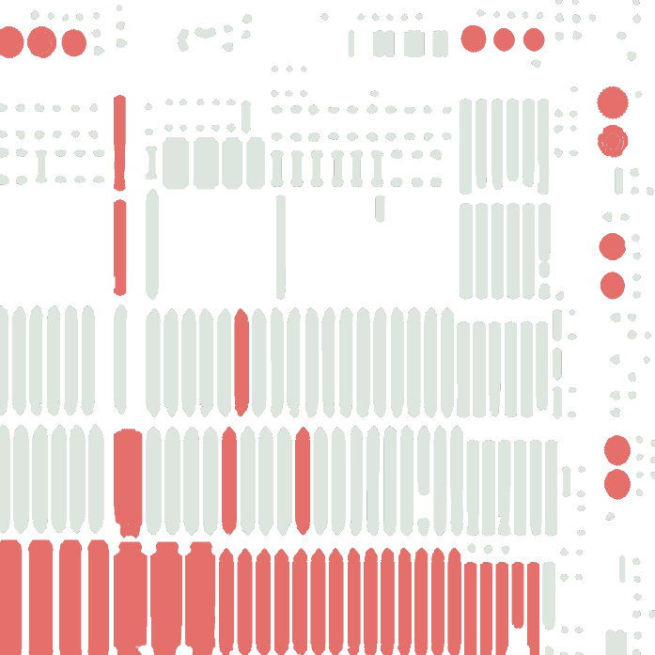

Albedo map

Normal map

UV Unwrap

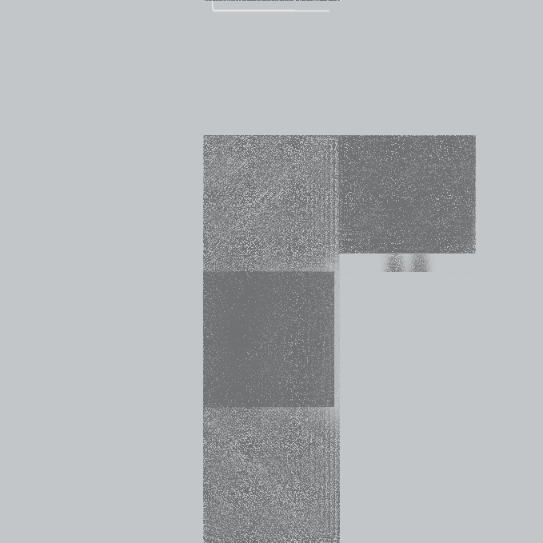

Albedo map

Normal map

UV Unwrap

Reception desk

Security monitors

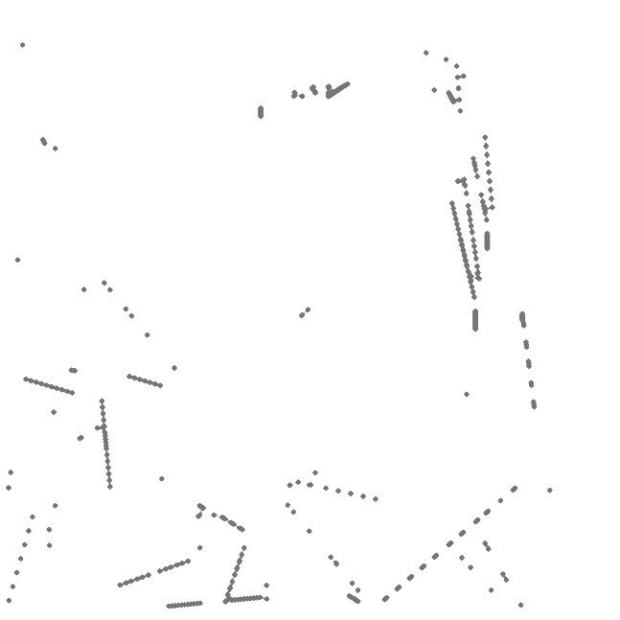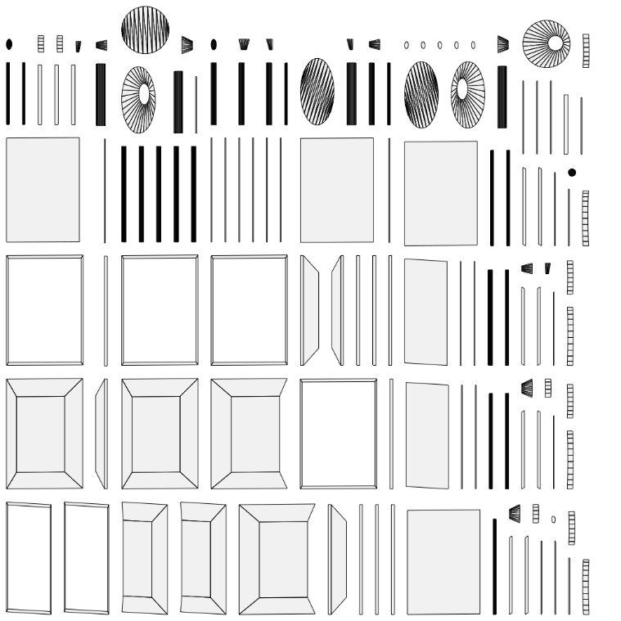

Albedo map

Normal map

UV Unwrap

Hospital bed

Normal map

UV Unwrap

Albedo map

Drawer

Normal map

UV Unwrap

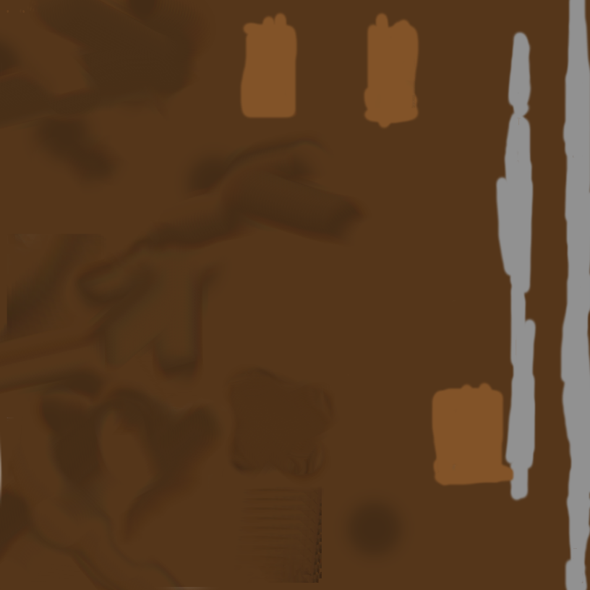

Albedo map

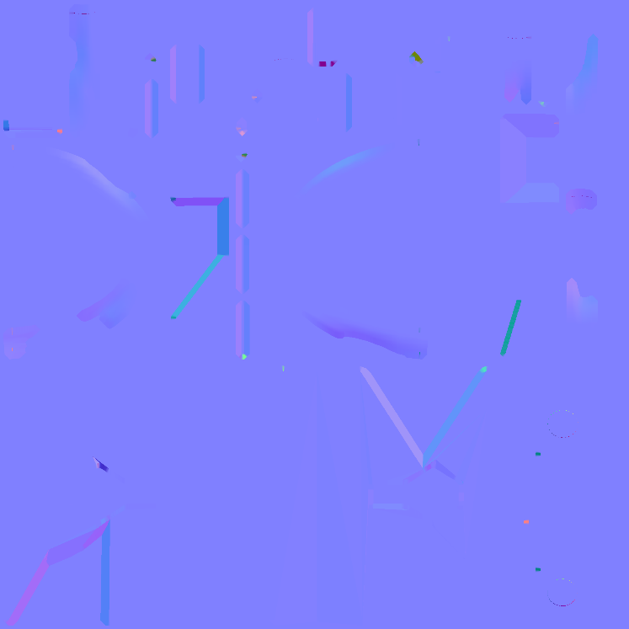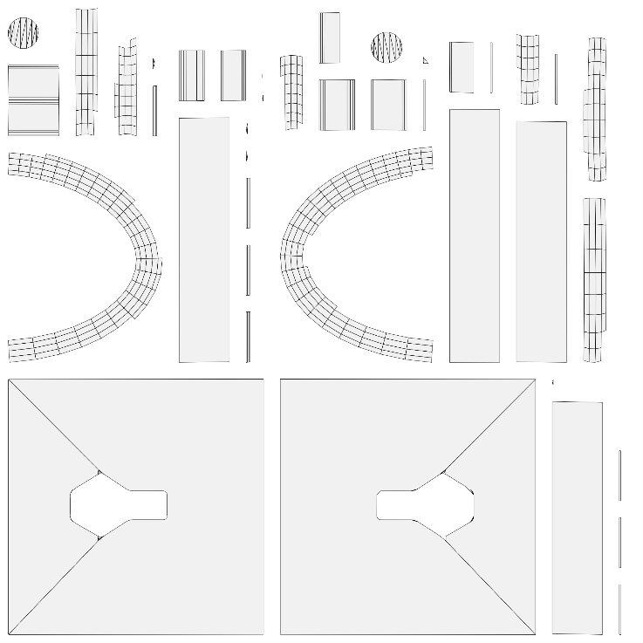

Albedo map

Normal map

UV Unwrap

Lock